**University of Santo Tomas**

**College of Education**

**BACHELOR OF SCIENCE IN FOOD TECHNOLOGY**

**PRACTICUM POLICY STATEMENTS AND GUIDELINES**

**Effectivity: First Term, AY 2016 – 2017**

**I. PRACTICUM RATIONALE**

1. **COURSE INFORMATION**

|  |  |
| --- | --- |
| Course Title | Practicum Training in the Food Industry |
| Course Code | PRACT-FT |
| Course Credit Units | 6 laboratory (300 hours) |
| Course Pre-requisites | FT 114C (Food Processing 3)  FT 115 (Food Analysis)  FT 116 (Food Safety) |
| Course Co-requisites | -NA- |
| Course Coordinator/Supervising Teacher | Ms. Elena G. Fernandez  Ms. Essence Jeanne P. Logan |

1. **PRACTICUM TRAINING RATIONALE AND OUTCOMES**

The Department of Food Technology of the University of Santo Tomas, College of Education offers its students, the opportunity to undergo industry exposure prior to graduation with the aim of familiarizing them to the actual food industrial operations and management thus deepening their formal and theoretical academic training.

At the end of the 300 practicum-hour, Food Technology practicumers shall:

* Participate in actual operations in food practicum sites.
* Document operations and practices observed in food practicum sites.
* Work collaboratively with food industry practitioners in carrying out various food processing operations.

1. **PRACTICUM TIMELINE**

|  |  |
| --- | --- |
| **Tasks and Activities** | **Time-Frame** |
| Practicum Application and Preliminary Requirements Submission | March – May |
| Practicum Application Screening | March – May |
| Practicum Application Approval | 4th week of May |
| Practicum Orientation | 2nd week of May |
| Practicum Conforme Signing and Submission | 4th week of May |
| Practicum Proper | June – July |
| Practicum Coordinator Visits | June – July |
| Post Practicum Reports and Other Requirements Submission | 2nd week of August |
| Practicum Grades Release and Posting | 3rd week of August |

**II. ON PRACTICUM APPLICATION**

**POLICY STATEMENT:**

The Food Technology Department maintains a rigorous application process for practicum that will ensure the academic preparation and physical and psychological fitness of the practicumer.

**POLICY GUIDELINES:**

1. The application period for practicum begins on the second semester of the academic year. The subject is taken during Special Term. Only students who have passed the pre requisites stated are qualified to apply.
2. Students are to select the training institution (also referred to as the HOST INSTITUTION) of their choice. However, final placement is decided upon the screening committee.
3. Students are required to submit the following documents to the practicum coordinator before the end of May:
4. **Practicum Application Form**

The student must fill out the practicum application form **(see Annex 1).** The student must indicate his name, student number, home/provincial address, telephone number and section on the space provided for in the application form. The student must list 5 referrals for their practicum. Referrals listed should include the name of the contact person, position, and company address. Referrals should be listed according to their priority. This application must be typewritten. It should be signed by the parent/guardian before submission.

1. **Transcript of Records/True Copy of Grades**

Transcript of record or true copy of grades can be availed at the Office of the Registrar.

1. **Medical Clearance**

Medical certificate stating the health condition of the student may be issued by the Student Health Service or any accredited medical clinic.

1. The screening committee, which is composed of the department chair, Food Technology faculty members, and the practicum coordinator/s shall assess the applicant’s ability to meet the requirements/standards of the training establishment of his choice.
2. Should the student meet the standards of the practicum institution, the application is approved. The approved application form is then submitted to the Department Chair who, in turn, prepares the recommendation letters addressed to the training institutions.
3. **Recommendation letters** shall be distributed to the students by the practicum coordinator. Students shall take charge of bringing their recommendation letters to their respective training institutions. Students are also requested to follow up their own application.
4. Notification of acceptance/denial is channeled thru the Dean’s office by the training institution.
5. Upon acceptance, the student is instructed to enroll the course during the Special Term.
6. Students and their parents/guardians are required to attend the Practicum Orientation Program in May, organized and facilitated by the practicum coordinator and the Department Chair.
7. The Practicum Program including guidelines and policies shall be discussed during the orientation. Additionally, Waivers **(Annex 2),** Practicum Evaluation Sheets **(Annex 3)**, and Memorandum of Agreement **(Annex 4)** are also presented in this **PRACTICUM MANUAL** provided during the orientation program.
8. Students may commence their practicum training immediately after enrollment and upon submission of waivers. Refer to the **Checklist of Requirements Before Starting Practicum** as guide.

**III. ON PRACTICUM PROPER**

**POLICY STATEMENT:**

The Food Technology Department offers an optimum off-campus practicum experience to its students enabling them to apply the theories and concepts learned in the professional and specialization courses.

**POLICY GUIDELINES:**

The student practicumer is expected to obtain practical work experience and instruction in **one or more** of the following food processing areas:

**1A Area: Raw Material Handling and Inspection**

***Competency:*** Demonstrate competence in grading and standardization process and general approach of acceptance of incoming raw materials

*Expected Engagements:*

* Participate in monitoring raw materials and food ingredient quality.
* Perform measurement of quality parameters/product characteristics following proper sampling methods and/or statistical tools.
* Record data and information.

**2A Area: Food Production**

***Competency:*** Demonstrate competence in food processing operations and technological advances in food manufacturing

*Expected Engagements:*

* Implement quality control practices in food production.
* Assist in operation of machines/instruments used in food processing.
* Apply unit operations and engineering principles in food processing.

**3A Area: Quality Assurance (Physico-chemical and Microbiological Analyses)**

***Competency:*** Demonstrate competence in food analysis and testing

*Expected Engagements:*

* Conduct physico-chemical and microbiological analyses following. standard methods and completes written reports of analysis.
* Record data and interpret results of physico-chemical and microbiological analyses.

**4A Area: Sensory Evaluation**

***Competency:*** Demonstrate competence in sensory perception and sensory evaluation methods

*Expected Engagements:*

* Participate in various sensory evaluation activities.
* Design sensory tests suitable for different test situations/test objectives.
* Prepare samples for sensory testing following proper methods and product sampling, coding and presentation.
* Record and tabulate sensory evaluation data.
* Analyze and interpret sensory evaluation results using appropriate statistical techniques.
* Integrate sensory evaluation in quality assurance and product development.

**5A Area: Finished Product Inspection**

***Competency:*** Demonstrate competence in quality assessment and product inspection techniques

*Expected Engagements:*

* Record data and completes quality control charts.
* Implement quality control in out-going finished products.
* Inspect and measure product quality.
* Identify possible causes of defects in finished product quality and recommend way to prevent them.

**6A Area: Packaging**

***Competency:*** Demonstrate competence in quality assessment techniques for food package, the process of package design and the requirements of food labeling

*Expected Engagements:*

* Perform test procedures for quality check of packaging material.
* Conceive food package design taking into account product properties, cost and labeling requirements.

**7A Area: Waste Management**

***Competency:*** Demonstrate competence in essentials of food waste treatment and current state of environmental management practices

*Expected Engagements:*

* Monitor disposal of food plant wastes.
* Check if manufacturing procedures meet legal and sanitary requirements.
* Perform standard methods of waste water analysis.
* Critique present water and waste control program.

**8A Area: Food Product Development**

***Competency:*** Demonstrate competence in innovating new food products and design process for product improvement, food ingredient substitution and cost reduction

*Expected Engagements:*

* Conceive new products.
* Develop formulations and/or methods for product improvement.
* Conduct product evaluation and testing.
* Conceptualize marketing strategies for new products.

**9A Area: Food Plant Hygiene and Sanitation**

***Competency:*** Demonstrate competence in preventing foodborne illnesses during processing and enforcing food sanitation procedures

*Expected Engagements:*

* Critique process flow and identifies practical hazards in different stages of food production.
* Determine if all food safety standards are met.
* Recommend corrective actions for any violations in the implementation of food safety regulations.
* Execute proper food safety monitoring and recording.

**IV. ON PRACTICUM PROFESSIONAL BEHAVIOR**

**POLICY STATEMENT:**

The Food Technology Department commits itself to forming future Food Technologists whose actions define a high degree of ethical and professional behavior.

**POLICY GUIDELINES:**

1. **Dress Code**

Students should follow the dress code required by the host institution.

1. **Personal Hygiene**

Students should maintain good personal hygiene consistent with GMP (Good Manufacturing Practices).

1. **Courtesy**

Student practicumers shall at all times treat their supervisors and other company staff with utmost respect.

1. **Punctuality**

Student practicumers must observe regularity and punctuality in attendance. He/She must arrive and leave the working place on time.

**V. ON PRACTICUM DISCIPLINE**

**POLICY STATEMENT:**

The Food Technology Department maintains a set of disciplinary actions that will ensure the holistic formation of its students.

**POLICY GUIDELINE:**

Any student practicumer reported to have displayed improper attitude and behavior inside the job-site, particularly toward the employees, or had grossly failed to abide policies and regulations of the host institution **shall be subjected to investigation and disciplinary action** by the University. The case shall be forwarded to the Student Welfare and Development Board for review and assignment of sanctions.

**VI. ON PRACTICUM DOSSIER**

**POLICY STATEMENT:**

The Food Technology Department ensures the comprehensive documentation of the practicum experience and the achievement of the course intended learning outcomes through the production of a practicum dossier.

**POLICY GUIDELINES:**

1. The Practicum Report comprises 30% of the final grade in PRAC-FT course, whereas the remaining 70% relies on the Company’s evaluation of the student trainee’s performance.
2. The Practicum Report shall be evaluated by the Practicum Coordinator based on the following criteria:

|  |  |
| --- | --- |
| Content *(Completeness of content and consistency of details)* | 70% |
| Format and style *(Readability, Creativity, and Organization of presentation)* | 30% |
| TOTAL | 100% |

1. The Practicum Report must contain the following components:
2. Title Page*
3. Table of Contents*
4. Acknowledgements*
5. General Information about the Training Institution

d.1 Name and Logo of the Company*

d.2 History of the Company

d.3 Mission and Vision*

d.4 Location*

d.5 Organizational Chart

d.6 Company Policies*

d.7 Plant/Laboratory Layout**

d.8 List of Facilities**

d.9 List of Equipment/Instruments**

d.10 Porducts*

d.11 QC Forms and Brochures**

e. Laboratory Procedures**

f. Accomplishment Report (Daily Diary)**

g. Personal Assessment of the Company and the Training Program**

h. Certificate of Completion**

i. Practicum Evaluation Form**

*\* To be presented as COMMON content, in the case when several students were trained under ONE COMPANY SITE but placed in different departments/divisions*

*\*\* To be prepared and presented INDIVIDUALLY depending on the student’s department/division placement, in the case when several students were trained under ONE COMPANY SITE*

**NOTE:** Student/s who had undergone training UNDER ONE COMPANY SITE is required to submit ONE report compilation, provided that the compilation includes the contents that are to be presented individually.

1. Preparation Guidelines
2. The **Title Page** shall contain this information:

PRACTICUM REPORT: (COMPANY NAME)

In Partial Fulfillment of the Requirements in PRAC-FT Course

for the Degree in Bachelor of Science in Food Technology

Submitted to the Department of Food Technology,

College of Education, University of Santo Tomas

Date of Submission

Name/s of Student/s

This information will also appear in the front cover of the hard bound report.

1. The Practicum report shall have a complete and accurate **Table of Contents.**
2. **Acknowledgements** shall be a formal expression of appreciation and gratitude to the trainer/s and people who had greatly contributed to the training program of the student/s during the course of practicum.
3. The **General Information about the Training Institution** shall present accurate and comprehensive background information of the company. The assistance of the supervisor may be needed to secure the following information:
   1. **History of the company**
   2. **Mission / Vision**
   3. **Location**
      1. Provide a complete sketch of the company’s location
   4. **Organizational chart**
   5. **Company policies**
   6. **Plant Laboratory Layout**
      1. A sketch of the floor layout shall be presented where the student was assigned during training
      2. Floor layouts shall be INDIVIDUALLY prepared by the student/s as per department or division placement
      3. The floor layout should be labeled properly and clearly. **The particular department/division and the name of the student/s placed therein should be indicated.**
   7. **List of Facilities**
      1. Facilities shall be INDIVIDUALLY prepared by the student/s as per department or division placement
      2. Photographs may be included in this section as per the approval of the company supervisor.
   8. **List of Equipment/Instruments**
      1. Equipment/instruments shall be INDIVIDUALLY prepared by the student/s as per department or division placement
      2. Photographs may be included in this section as per the approval of the company supervisor.
   9. **Products**
      1. Present food products being produced by the company
      2. Photographs may be included in this section
   10. **QC Forms/Brochures**
       1. Attach actual forms/brochures used by the department by pasting on a page
4. The **Laboratory Procedures** describe the specific activities performed by the student/s during training. This section of the report should enumerate the actual activities or assignments performed. pH analysis, Brix analysis, tests for texture, microbiological analyses, sanitation monitoring, store audit, may serve as examples. The procedures need not be “Laboratory” by nature, as long as these activities were part of the training program.
   * 1. Procedures shall be INDIVIDUALLY prepared by the student/s as per department or division placement
     2. This section shall present the **step-by-step procedures** of the activity as performed by the student.
     3. In the event that confidentiality of procedures is observed, the general steps performed can be described without full detail.
     4. Schematic diagrams may be used to present procedures, as appropriate.
5. The **Accomplishment Report** is similar to a Daily Diary. A short paragraph (approx. 6-10 sentences) may serve as an entry for one day. An entry may be longer depending on the nature of the activities performed by the student for a specific day. Make it accurate and specific as possible to make the diary relevant and meaningful.
   * 1. **EACH STUDENT under one company site is required to present his/her Daily Diary.**
     2. **The start and end dates of practicum training should be clearly stated in the diary**
     3. As to clearly describe the hours rendered by the student per day, the official time-in and time-out may be mentioned.
6. The section for **Personal Assessment of the Company and the Training Program** is a personal commentary of the overall practicum training experienced by the student.
   * 1. **EACH STUDENT under one company site is required to present his/her personal assessment.**
     2. The student shall indicate the highlights of his/her training experience, or the activities that one deemed the most significant to one’s growth and learning
     3. The student can give his/her personal observations and judgments of the company’s activities, company’s culture and people, and how one was influenced by these
     4. *TIP: Make your assessment positive yet insightful, because your written report may be reviewed by the supervisor after your training.*
7. When submitting the report, a photocopy of **Certificate of Completion** should be attached.
   * 1. **EACH STUDENT under one company site, should attach a photocopy of his/her certificate.**
     2. The Certificate of Completion should clearly indicate the company, name of the student trainee, and the total number of training hours rendered. One should have completed 300 man hours.
     3. In the event that the report is already due for submission and the Certificate is not yet secured, the Certificate may be personally submitted to the Practicum Coordinator leaving a blank page in the report compilation.
8. Attach the signed and sealed envelope containing the **PRACTICUM EVALUATION FORM** as accomplished by the supervisor.
   * 1. **EACH STUDENT under one company site, should attach his/her Practicum Evaluation Form.**
     2. In the event that the report is already due for submission and the evaluation sheet is not yet secured, the evaluation sheet may be personally submitted to the Practicum Coordinator leaving a blank page in the report compilation.

**NOTE:** The Practicum Evaluation Forms should be placed in a **SIGNED and SEALED envelope** prior to submission. Any evidence of tampering shall render the form VOID and shall NOT BE ACCEPTED for final grade computation.

1. The contents of the Practicum Report shall be labeled accordingly as enumerated above. Each content shall be graded accordingly (***See Practicum Report Evaluation***), therefore the student needs to make sure the contents are complete and in order.
2. Submission Guidelines
3. It is the responsibility of the student to ask the approval of his/her superiors before final submission of the practicum report to the Department. **The student shall see to it that no confidentiality agreement was breached in the preparation of the practicum report.**
4. The Practicum Report shall be submitted **hard bound, yellow color,** with gold embossed text on the outer covering. The outer front cover of the report contains the contents of the title page. Use short bond paper. Follow 1.5-inch margin at the left side and 1 inch for the rest of the sides. The body of the report should be printed in black ink. Follow single spacing for the body of text. Use scholarly font (Arial or Times New Roman) with 11-12 font size as appropriate.
5. Practicum reports shall be submitted to the Practicum Coordinator **one week after the last day of practicum training.** There will be grade deductions for reports submitted late.
6. **Report to the Practicum Coordinator immediately regarding submission of LATE Certificate of Completion and Practicum Evaluation Form.**
7. The practicum coordinator sets the deadline for the submission of practicum reports and other requirements. If the student fails to submit the report and other requirements on the said deadline, the student shall be given an *INCOMPLETE GRADE*.
8. Graduating students must complete their practicum grades at least 1 month before the graduation date.

**VII. ON PRACTICUM GRADING**

**POLICY STATEMENT:**

The Food Technology Department maintains a system of grading that will ensure the holistic and objective assessment of the performance of the student practicumers and serve as guide in their pursuit of excellence.

**POLICY GUIDELINES:**

1. The final grade of the student shall be based on Company Evaluation (70%) and Practicum Report (30%).
2. Using the **Practicum Evaluation Sheet,** the training institution shall evaluate the student’s performance based on the criteria below (**Annex 3**):

Quality and Quantity of Work ………….40%

Knowledge of Work …………………….. 40%

Work Habits and Personality …….……...20%

1. The practicum coordinator shall evaluate the **Practicum Report** submitted by the student based on the following criteria:

Content………………………………………….70%

Format and Style ……………………………...30%

1. The practicum coordinator sets the deadline for the submission of practicum reports. If the student fails to submit the report on the said deadline, he shall be given an *INCOMPLETE GRADE*. Students with *INCOMPLETE GRADE* must complete their practicum grades at least within the first semester of the next academic year.

**VIII. ON PRACTICUM-RELATED PROTOCOLS**

**POLICY STATEMENT:**

The Food Technology Department implements practicum-related protocols that will support the effective and smooth conduct of off-campus practicum program and ensure harmony with existing policies of the University and College.

**POLICY GUIDELINES:**

1. The Practicum Coordinator shall have the following duties and responsibilities:
2. prepares application letter of the student to the training institution
3. prepares the Memorandum of Agreement (**Annex 4**) between the University and the Host Institution
4. plans and conducts practicum orientation together with the Department Chair
5. conducts visit during the practicum period and fills out practicum visit report
6. coordinates with the training institution regarding the performance and progress of the student
7. checks practicum report
8. schedules and administers exit interview with the student practicumer to discuss feedback.
9. computes and encodes practicum grades
10. The practicum coordinator together with the student shall set a day and time for a visit to be possible. The objective of the coordinator is to personally check working conditions of the student, and at the same time to talk with the direct supervisor regarding performance of the student and nature of his assignments during practicum.
11. A student showing **due cause** can request to be transferred from a placement at any time without penalty. However, **such decisions are not taken lightly and every situation is very carefully assessed.** Any request for a change to another placement during the course of a practicum must be discussed initially with the Practicum Coordinator.

Any decision must be acceptable to all parties, including the Chairperson of the Department and the Dean of the College. While there may be a variety of reasons for students requesting a change of placement, a situation where the student is not coping with the environment or the work **cannot be judged sufficient cause** to find a second placement. Inability to function in a work environment means failure of the practicum and subsequently the course.

The Practicum Coordinator may also remove a student from a placement if a mismatch is found. This is only done in consultation with the parties concerned.

If placement is agreed upon by all parties, the student shall undergo the same application steps and requirements for a new practicum site.

1. It is the student’s responsibility to notify the Practicum Coordinator if illness prevents attendance at the placement. A medical certificate must be presented if the student is absent from work for **more than three days** due to illness. It is also the student’s duty to notify his/her host organization regarding his medical condition that prevents him to render his practicum hour

**ANNEX 1**

**Practicum Application Form**

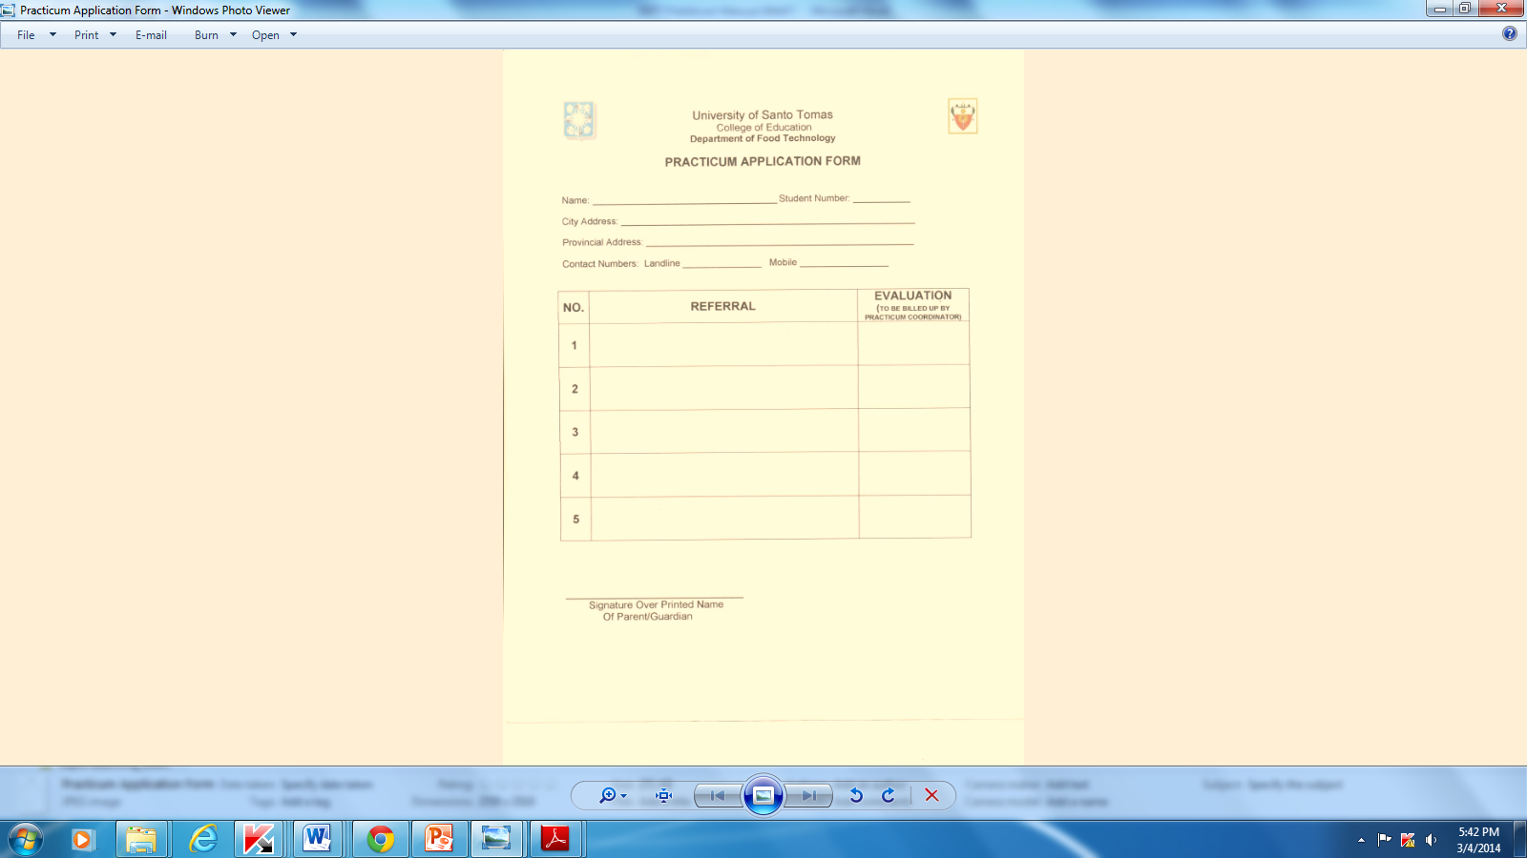

**SAMPLE ONLY**

**ANNEX 2**

**Practicum Waivers**

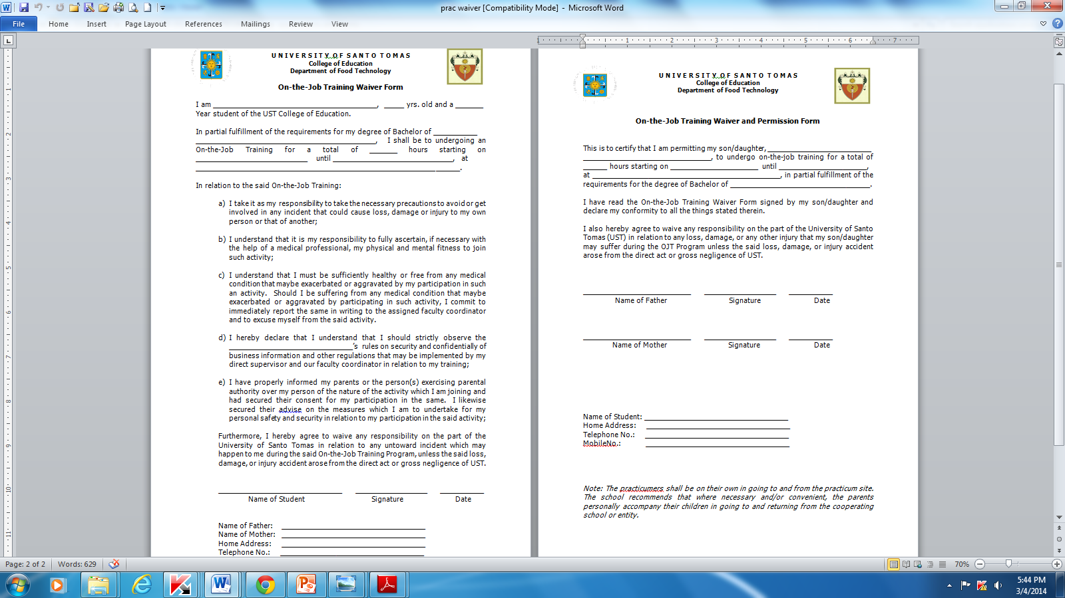

**SAMPLE ONLY**

**ANNEX 3**

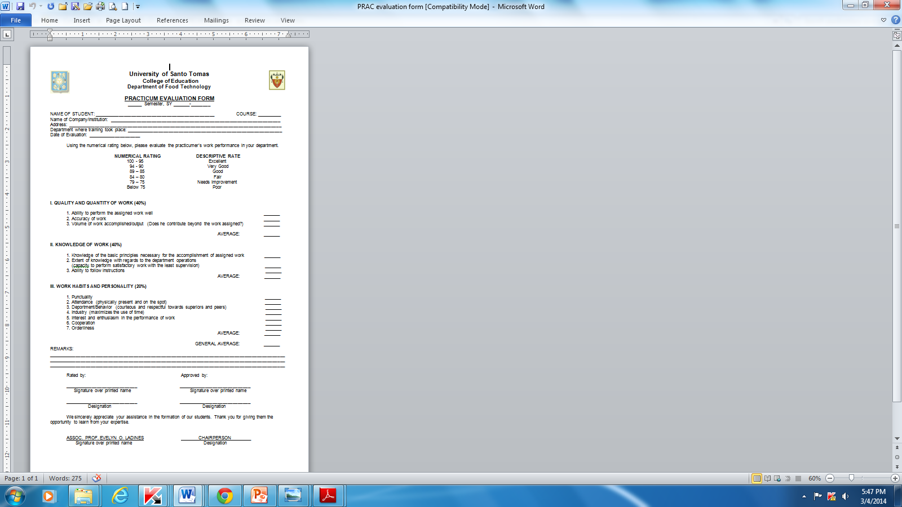**Practicum Evaluation Sheet**

**SAMPLE ONLY**

**ANNEX 4**

**Memorandum of Agreement**

### MEMORANDUM OF AGREEMENT

**ON**

**OFF CAMPUS PRACTICUM**

**FOR BACHELOR OF SCIENCE IN FOOD TECHNOLOGY**

**UNIVERSITY OF SANTO TOMAS (UST),** address at España, Manila represented in this agreement by **REV. FR. HERMINIO V. DAGOHOY, O.P.,** Rector of the universityand hereinafter referred to as the “First Party”

**AND**

The **BEATRICE KITCHEN.**, address at #10 F. Legaspi St., Maybunga, Pasig City represented herein by **MS. ELENOR O. UNTALAN** in his/her capacity as the Plant Manager hereinafter referred to as “Second Party”

**SAMPLE ONLY**

**WITNESSETH: That**

Whereas, the **First Party**, an educational institution of higher learning offers a Bachelor of Science in Food Technology program in which qualified students are required to undergo industry exposure prior to graduation in order to become adequately familiar to the actual food industrial operations and management, thereby augmenting their formal training;

Whereas, the **Second Party**, the Company agreed to accept students of the first party as trainees in support of its Practicum Training Program which aim to forge strong academe-industry linkage and complement existing course curricula to match industry demand;

Now, therefore, for and in consideration of the foregoing premises, the two parties mutually agree on the following:

1. **First Party**
2. Recommend qualified students who will undergo the training program taking into consideration the requirements of the Second Party in terms of qualifications and number of students.
3. Designate a practicum coordinator who will be assigned with the following responsibilities:
4. Orientation of students about the rules, proper attitude and behavior inside the job-site, particularly toward the employees;
5. Monitor activities and performance of students during the training program in the company.
6. Submit to the company requisite documents for this program.

**SAMPLE ONLY**

1. **Second Party**
2. Provide necessary training in different areas of food manufacturing for a period of **300** man-hours.
3. Assign a trainer who will closely supervise/monitor the students throughout the duration of the practicum.
4. Involve the students in activities and tasks to develop their work attitude and creative abilities to become a professional employee.
5. Enforce the rules that will govern the conduct of the program in their premises. The said rules shall be made known to UST and student-trainees before the start of the training.
6. Provide the UST Practicum coordinator with performance evaluation report in connection with the training requirements of the students.
7. Issue Certificate of Completion to the student-trainee upon fulfillment of all the training requirements.
8. **Under this Memorandum of Agreement, the following terms and conditions are likewise included:**
9. There will be no employer-employee relationship between the company and the student trainees of UST.
10. The company is not required to give any compensation, salary, allowances and any form of incentives as payment for the services of the student-trainee. Provided that, the company may as an act of generosity on their part provide incentives such as meal, transportation, allowances, accommodations, etc.
11. The Parties may pre-terminate the Agreement upon any reasonable ground, provided that the terminating party shall give an advance 30-day prior written notice to the other party.

This agreement shall take effect on ______________________ up to ____________________.

(Date Started) (Date Finished)

Now, therefore, for and in consideration of the foregoing premises, the two parties mutually agree to enter into a Memorandum of Agreement on ___________________________.

**UNIVERSITY OF SANTO TOMAS BEATRICE KITCHEN**

**First Party Second Party**

**SAMPLE ONLY**

By: By:

**REV. FR. HERMINIO V. DAGOHOY, O.P. MS. ELENOR O. UNTALAN**

Rector Plant Manager

Signed in the Presence of:

**PROF. CLARITA D. CARILLO, Ph.D. MS. MARIFE RODA**

Vice-Rector for Academic Affairs & Research Administration Officer

**PROF. ALLAN B. DE GUZMAN, Ph.D. MS. DHAPNEY TAMAYO**

Dean, College of Education QA Officer

**REPUBLIC OF THE PHILIPPINES**

____________________________________

**ACKNOWLEDGMENT**

This __________day of _________________________________, 2012 at the _____________

___________________________________________________personally appeared before me

Name CTC Number Issued at Issued on

___________________________ ___________ ____________ ___________

All known to me to be the same persons who executed the foregoing instrument, and they acknowledged to me that the same is their free and voluntary deed.

**WITNESS MY HAND AND SEAL**

**ANNEX 5**

**Checklist of Requirements BEFORE Practicum**

Are you ready to begin your practicum?

Mark the appropriate boxes to verify if all your requirements are complete BEFORE starting your practicum

* **Read and understood the PRACTICUM MANUAL**
* **Registration form as proof of being officially enrolled for Special Term secured**
* **Practicum waivers submitted to practicum coordinator**
* **Memorandum of Agreement processed and signed**
* **Practicum Evaluation Sheets forwarded to your direct supervisor for grading**

**ANNEX 6**

**Checklist of Requirements AFTER Practicum**

Have you fulfilled the requirements for practicum?

Mark the appropriate boxes to verify if all your requirements are complete upon ending your practicum course.

* **Memorandum of Agreement signed and submitted**
* **Visited by Practicum Coordinator**
* **Accomplished Practicum Evaluation Sheet submitted in a signed and sealed envelope**
* **Certificate of Completion submitted**
* **Practicum Report submitted**
* **No pending obligation in the host institution**